Contents

Color combination recommendations 1

Interface recommendations 6

IOS & Android & Windows Phone 6

Yummly 6

IOS 6

Taasky 7

Android 7

Windows Phone 7

Cross Platform Application 7

Web Application 7

# Color combination recommendations

#### [Red Bowl Challenge](http://www.redbowlchallenge.org/)

[](http://www.redbowlchallenge.org/)

#ED1C24

#831618

#FFFFFF

#### [Tree House](http://teamtreehouse.com/)

**[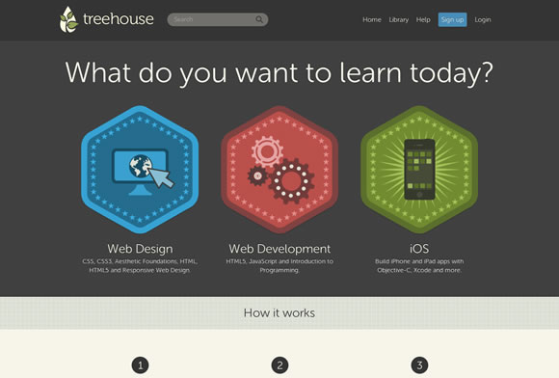](http://teamtreehouse.com/)**

#00ACE9

#D43F3F

#6A9A1F

#F6F6E8

#404040

#### [Enlightening Quotes](http://www.enlighten-my-mind.com/)

**[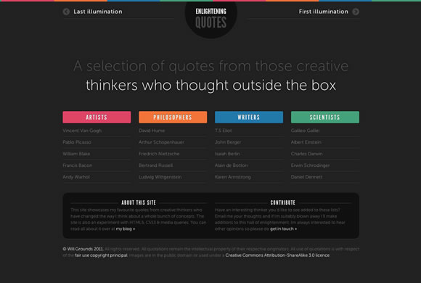](http://www.enlighten-my-mind.com/)**

#222222

#D11250

#DB5800

#006899

#008F68

#### Hyundai Veloster



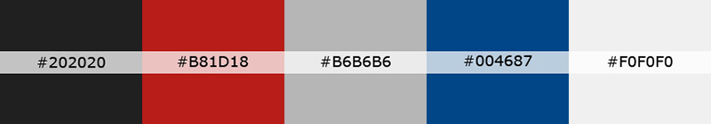

#### Barni Design

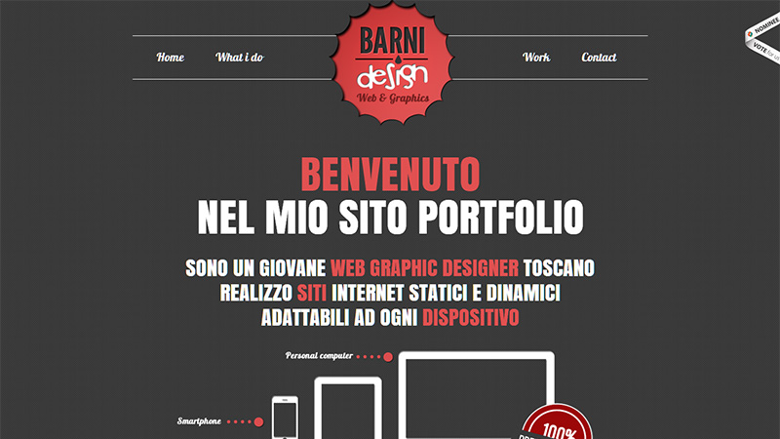

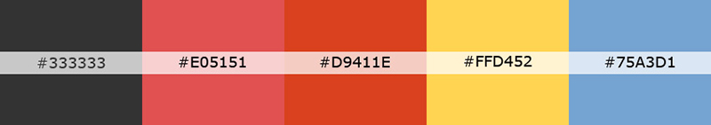

#### Duplos

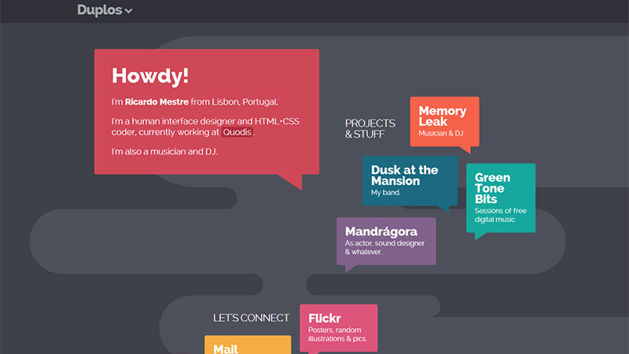



# Interface recommendations

## IOS & Android & Windows Phone

### Yummly

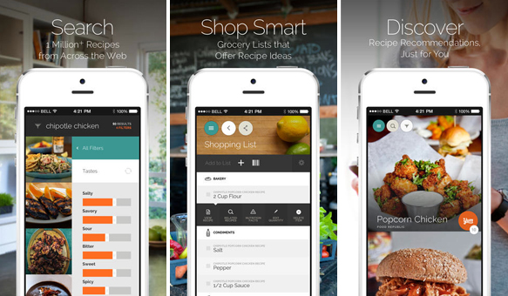

URL:

<http://www.yummly.com/mobile/>

Attention:

* Welcome screen
* Take tour screen series
* Left side menu
* Recipe flow
* Right menu for each recipe, and when click on it all other recipe have been darker
* Share screen application list

### Wire

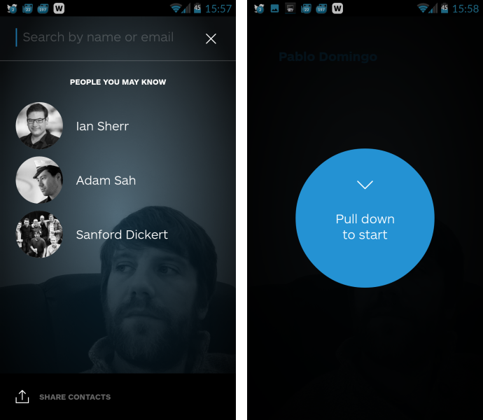

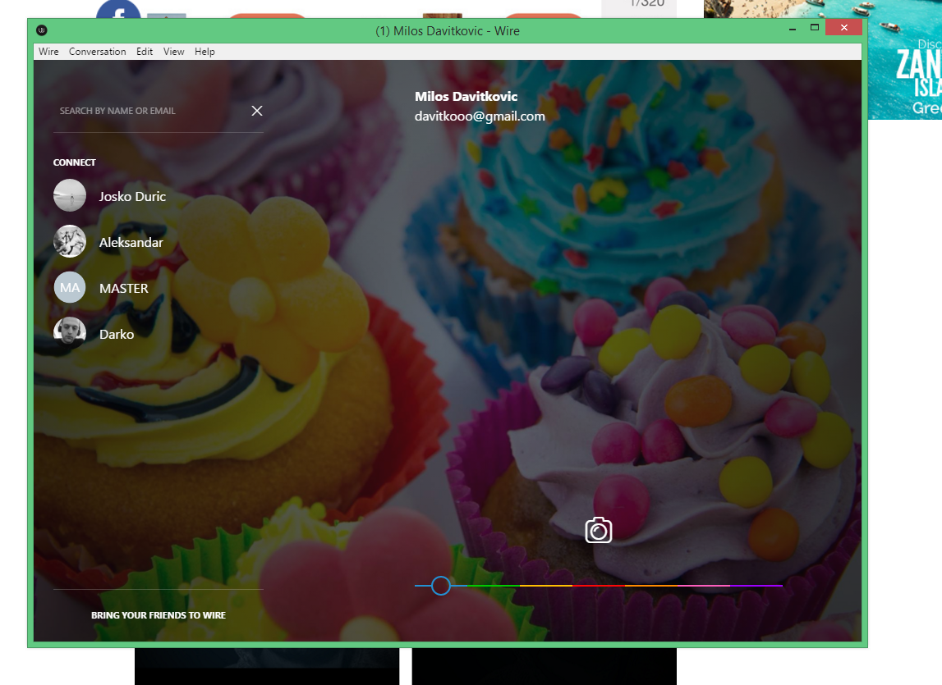

URL:

<https://wire.com/download/>

Attention:

* Everything is simple but harmoniously!

## IOS

### Paper – stories from Facebook

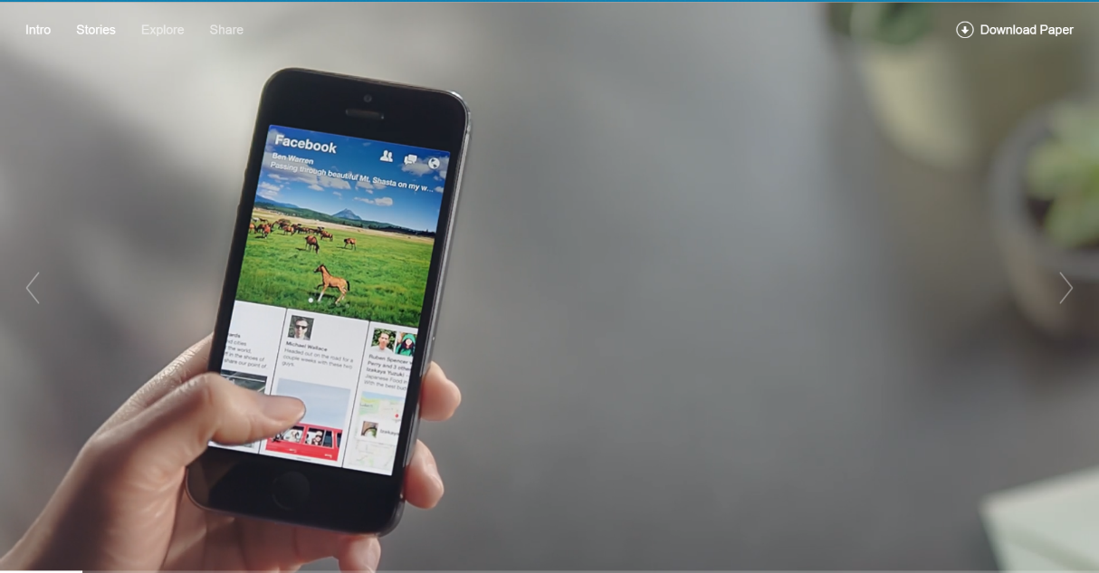

URL:

<https://www.facebook.com/paper>

<https://itunes.apple.com/us/app/paper-stories-from-facebook/id794163692>

Attention:

* Interesting Web site for information about the application, we should have same

### Taasky

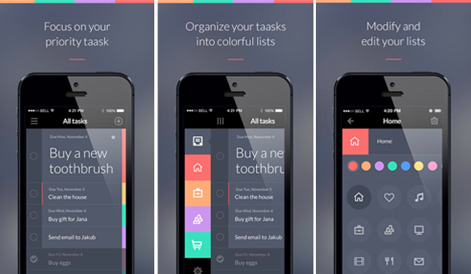

URL:

http://www.taasky.com/

### Pacemaker

**Pacemaker Music AB**

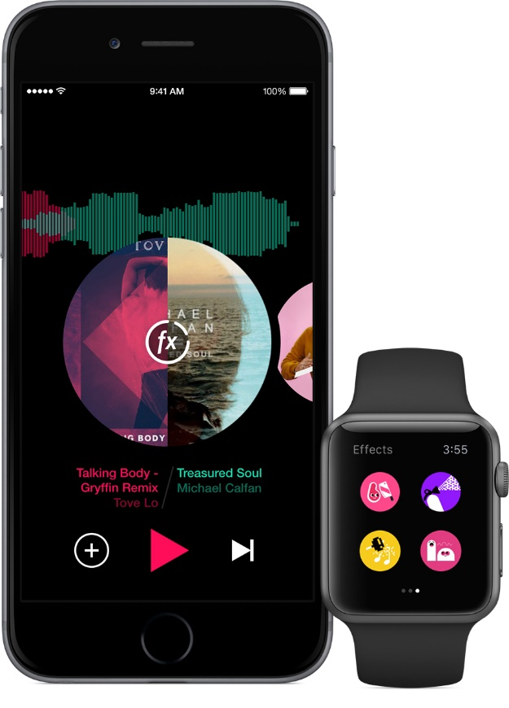

**URL:**

<https://itunes.apple.com/us/app/pacemaker-dj/id593873080?mt=8>

**Attetion:**

...a creative, minimalist visual design style optimized for each device type, compelling color scheme, and realistic animations...

## Android

### Airbnb



URL:

<https://play.google.com/store/apps/details?id=com.airbnb.android&hl=sr>

Attention:

* Main screen information flow

## Windows Phone

## Cross Platform Application

## Web Application